Yenepoya
Project – High Level Design
on
Cloud Forensic Automation For
Healthcare Breaches

Student Name: Nirmal Manoj

Industry Mentor: Mr Shashank | Guided by: Ms Vijayalaxmi

Table of Contents

- Introduction .................................................. 1
1.1 Scope of the Document .................................... 1
1.2 Intended Audience ........................................ 2
1.3 System Overview .......................................... 2
- System Design ................................................ 3
2.1 Application Design ........................................ 3
2.2 Process Flow .............................................. 4
2.3 Information Flow .......................................... 5,6,7
2.4 Components Design .........................................8
2.5 Key Design Considerations ................................. 9
2.6 API Catalogue ............................................. 10
- Data Design .................................................. 11
3.1 Data Model ................................................ 11
3.2 Data Access Mechanism ..................................... 11
3.3 Data Retention Policies ................................... 11
3.4 Data Migration ............................................ 12
- Interfaces ................................................... 12
- State and Session Management ................................ 12
- Caching ...................................................... 13
- Non-Functional Requirements ................................. 13
7.1 Security Aspects .......................................... 13
7.2 Performance Aspects ....................................... 14
- References ................................................... 14

1. Introduction
Cloud Forensics Automation for Healthcare Breaches is a cybersecurity system designed to automate the collection, analysis, and reporting of digital forensic evidence from healthcare data environments. Healthcare systems store highly sensitive information such as Electronic Health Records (EHR), medical imaging data, laboratory reports, billing records, and prescriptions, making them prime targets for cyberattacks and data breaches.
The system provides a web-based platform for performing forensic investigations on healthcare data by scanning directories, analyzing files, and identifying potential risks. It extracts file metadata, generates cryptographic hashes (SHA256 and MD5), detects anomalies such as unusual file sizes and timestamp manipulation, and applies multi-factor risk scoring to classify files based on threat level.
This High Level Design (HLD) document outlines the system architecture, component interactions, data flow, and design considerations. The platform is implemented using Python and Flask, and includes a browser-based dashboard for real-time monitoring, visualization, and report generation in multiple formats such as CSV, XLSX, and PDF.
The system aims to support efficient forensic analysis, improve incident response, and enhance data security in healthcare environments.

1.1 Scope of the Document
This document covers the complete high-level architectural design of the Cloud Forensics Automation system. It describes:
- System architecture including CLI and Web application layers
- Application design with module-level component breakdown
- Process and information flow for forensic scanning operations
- Data design including database schema and evidence data model
- API catalogue for all REST and SSE endpoints
- Security aspects including authentication, hashing, and access control
- Non-functional requirements including performance and scalabilityThe document does not cover deployment infrastructure, cloud provider-specific configurations, or production hardening procedures.

1.2 Intended Audience
This document is intended for a range of stakeholders involved in the design, development, and use of the system.
• Software developers and system architects responsible for building, maintaining, and extending the platform
• Cybersecurity professionals and forensic investigators who analyze data breaches and assess risks
• Academic evaluators and project reviewers assessing the system design and implementation
• Healthcare IT administrators responsible for managing and securing healthcare data systems
The document provides a high-level understanding of the system architecture, components, and workflows to support effective development, evaluation, and usage.

1.3 System Overview
The Cloud Forensics Automation system performs automated forensic analysis of file systems in healthcare environments through a web-based interface. The system is designed to assist investigators in identifying suspicious activities and potential data breaches by analyzing files stored in healthcare systems.
The system operates by scanning a target directory, extracting detailed file metadata such as timestamps, permissions, file size, and entropy, and generating cryptographic hashes (SHA256 and MD5) to ensure data integrity. It applies a multi-factor risk scoring mechanism to evaluate each file based on various parameters including anomaly detection, modification timelines, and file sensitivity.
Files are further classified into healthcare-specific categories such as medical records, billing data, and laboratory reports to provide better context during analysis. The system also detects anomalies such as zero-byte files, unusually large files, and timestomping (manipulation of file timestamps), which may indicate malicious activity.
The results of the analysis are presented through an interactive web dashboard that allows users to visualize data using charts, tables, and logs. The system also generates structured forensic evidence reports in multiple formats including CSV, XLSX, and PDF for documentation and further investigation.
All scan sessions and evidence records are stored in a SQLite database using SQLAlchemy ORM, enabling efficient data management and retrieval for future analysis.

2. System Design
The system follows a modular, layered architecture for real-time forensic analysis in a web-based environment. It separates the user interface, processing logic, and data handling to ensure scalability and maintainability.
The architecture includes Presentation, Application, Processing, Data, and Reporting layers, each performing specific functions.
The frontend dashboard enables users to initiate scans and view results, while the Flask backend manages API requests and controls the forensic workflow.
Core processing is handled by modules such as scanner, metadata extractor, hashing module, and risk engine, which operate in a pipeline to analyze files.
Real-time updates are provided using Server-Sent Events (SSE), and the system generates reports and logs for analysis.
2.1 Application Design
The application is structured as follows: 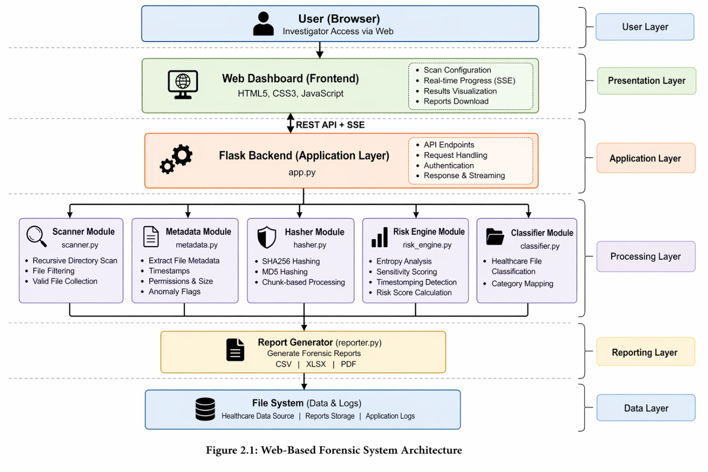

2.2 Process Flow
The forensic investigation process follows a well-defined sequential pipeline. The diagram below illustrates

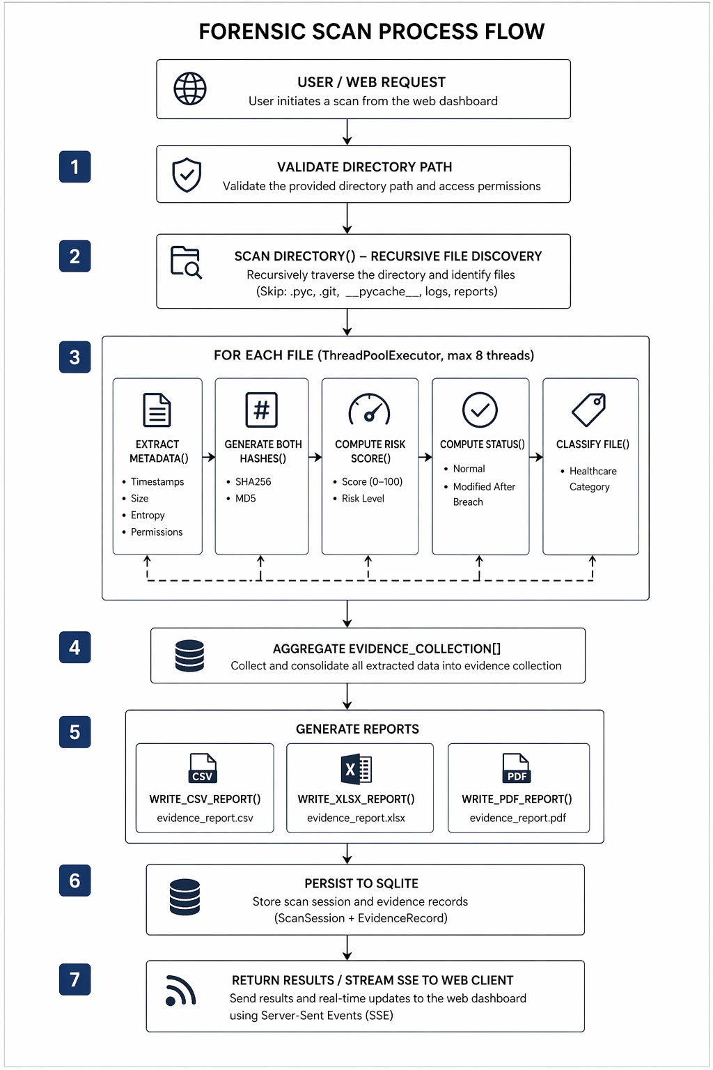

2.3 Information Flow
The information flow describes how data moves between components during a forensic scan:
Source | Destination | Data Type | Description
User / Browser | app.py | Directory Path | Target path provided for forensic scan
app.py | scanner.py | Scan Request | Initiates directory scanning process
scanner.py | app.py | File Path List | List of discovered files
app.py | metadata.py | File Path | Sends file for metadata extraction
metadata.py | app.py | Metadata Dict | Timestamps, size, entropy, permissions
app.py | hasher.py | File Path | Sends file for hash generation
hasher.py | app.py | Hash Dict | SHA256 and MD5 hash values
app.py | risk_engine.py | Metadata + Hash | Input for risk calculation
risk_engine.py | app.py | Risk Score + Level | Risk score (0–100) and classification
app.py | classifier.py | File Info | Sends file data for classification
classifier.py | app.py | Category | Healthcare category classification
app.py | reporter.py | Evidence List | Aggregated file data
reporter.py | File System | CSV/XLSX/PDF | Generated forensic reports
app.py | Database | ORM Objects | ScanSession and EvidenceRecord stored
app.py (SSE) | Web Client | JSON Events | Real-time updates streamed to dashboard

2.4 Use Case Diagram
The following use case diagram illustrates the interactions between system actors (Investigator and System) and the primary use cases of the application:
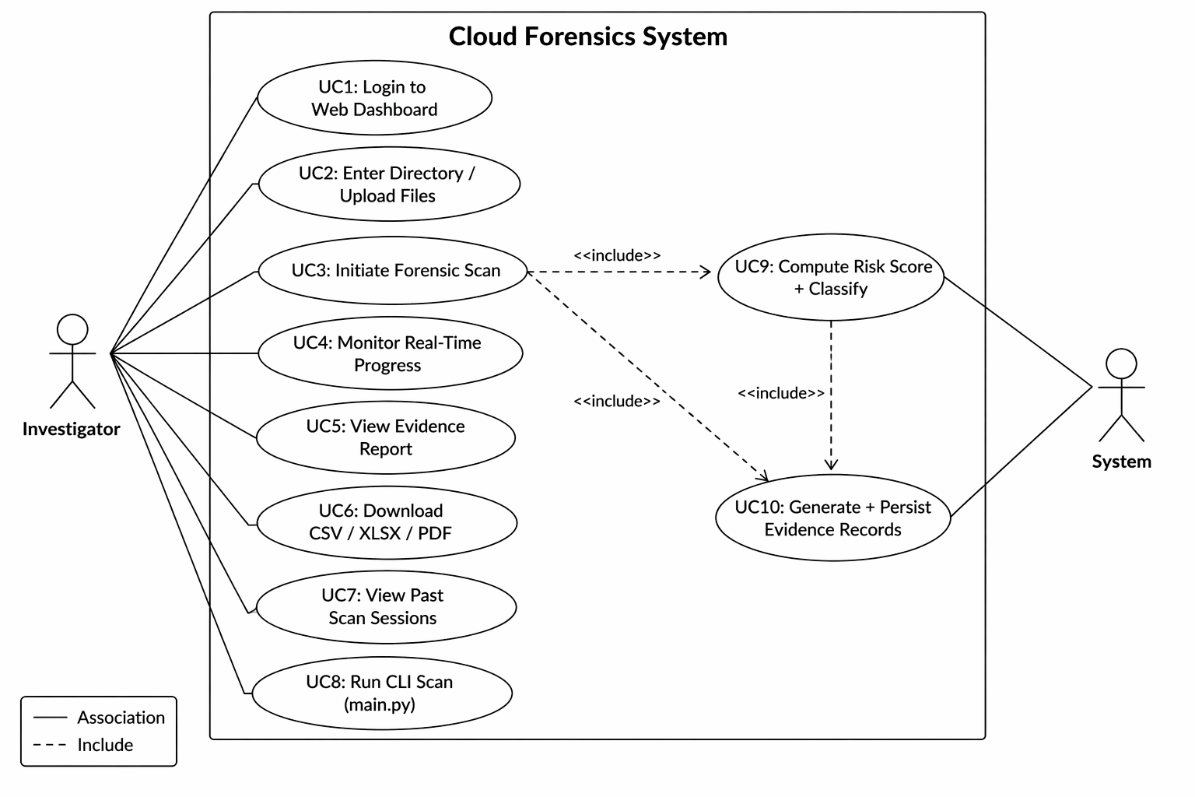

2.5 Sequence Diagram
The sequence diagram below illustrates the interaction between components during a web-triggered forensic scan:
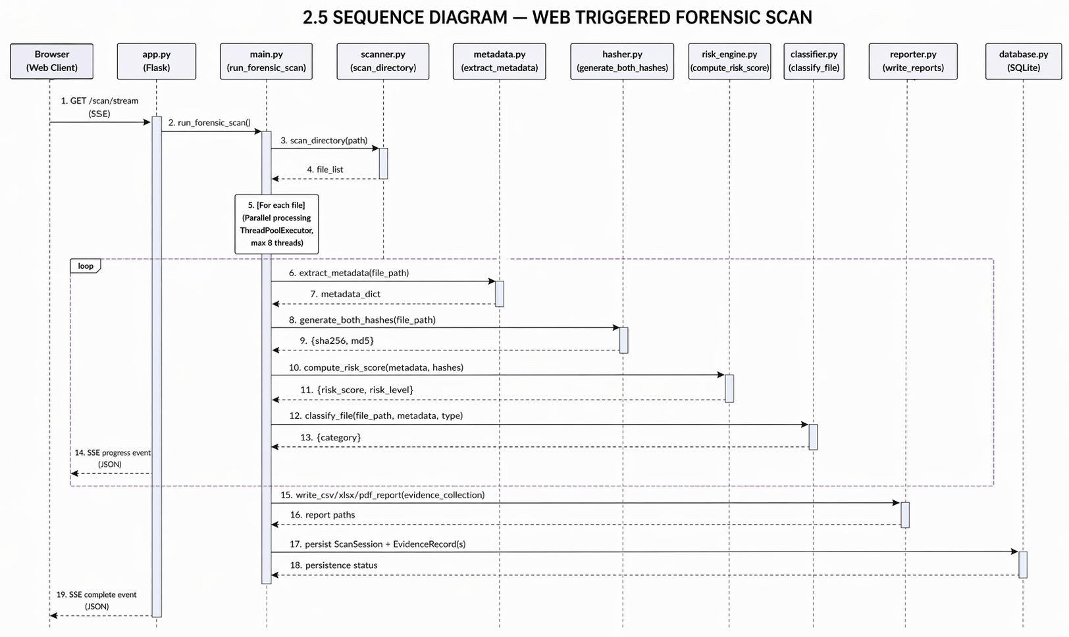

2.6 Components Design
The system is composed of the following core components:
Component | File | Responsibility
Configuration | config.py | Central constants: case ID, paths, breach date, Flask secret key, skip lists
Directory Scanner | modules/scanner.py | Recursively discovers files, skips system folders and non-evidence extensions
Metadata Extractor | modules/metadata.py | Extracts file timestamps, size, permissions, Shannon entropy, and detects timestomping
Hash Generator | modules/hasher.py | Computes SHA256 and MD5 cryptographic hashes in 4KB chunks for evidence integrity
Risk Engine | modules/risk_engine.py | Scores files 0–100 based on breach timeline, file type sensitivity, size anomaly, entropy
File Classifier | modules/classifier.py | Maps files to healthcare categories: EHR, Billing, Lab, Radiology, Pharmacy, etc.
Forensic Engine | main.py | Orchestrates parallel processing using ThreadPoolExecutor, aggregates results, triggers reporting
Report Generator | modules/reporter.py | Produces structured CSV, styled XLSX (openpyxl), and professional PDF (ReportLab) reports
Web Application | app.py | Flask app with login, SSE scan streaming, REST API endpoints, file upload, session management
Database Layer | database.py | SQLAlchemy ORM models: User, ScanSession, EvidenceRecord persisted in SQLite

2.7 Key Design Considerations
• Modularity: Each forensic function is implemented as an independent module, enabling easier maintenance, testing, and future extension.
• Parallel Processing: ThreadPoolExecutor is used to process multiple files concurrently, improving performance for large-scale directory scans.
• Real-Time Feedback: Server-Sent Events (SSE) are used to stream live scan progress to the web dashboard without the need for repeated polling.
• Evidence Integrity: SHA256 and MD5 hashes are generated for every file to ensure data integrity and detect tampering.
• Healthcare-Aware Analysis: The system supports healthcare-specific file types (e.g., .hl7, .dcm, .dicom) and classifies files into relevant categories for better analysis.
• Forensic Timestamp Analysis: File modification times are compared against the breach timeline to identify suspicious or post-breach activities.
• Timestomping Detection: Files with inconsistent timestamps (e.g., creation time later than modification time) are flagged as potentially manipulated.
• Scalability: The modular and layered architecture allows the system to handle increasing data volumes and supports future enhancements.
• Security Considerations: All operations are performed in read-only mode to preserve evidence integrity and prevent accidental modification of original data.
• Error Handling and Logging: The system maintains logs of all operations and handles errors gracefully to ensure reliability and traceability.
• Performance Optimization: Efficient file handling and chunk-based processing are used to ensure stable performance when scanning large files and directories.
• Data Consistency: Centralized processing through the backend ensures that all modules operate on consistent and synchronized data during analysis.
• Extensibility: The system is designed to allow easy integration of additional analysis modules such as advanced threat detection or machine learning-based classification.
• User Experience: The web dashboard is designed to provide clear visualization of results using tables, charts, and real-time updates for better usability.

3. API Catalogue
The web application exposes the following REST and SSE API endpoints. All endpoints require authentication via Flask session unless specified otherwise.

Method | Endpoint | Description | Auth Required
GET / POST | /login | Displays login page and validates user credentials to create session | No
GET | /logout | Ends user session and redirects to login page | Yes
GET | / | Loads main dashboard with case details and investigator information | Yes
GET | /api/stats | Returns summary data including total scans, file counts, and risk distribution | Yes
GET | /api/scan/stream?path=... | Initiates forensic scan and streams real-time progress using SSE | Yes
GET | /api/scans | Retrieves list of all previous scan sessions | Yes
GET | /api/scans//evidence | Retrieves detailed evidence records for a specific scan | Yes
POST | /api/upload | Uploads files for scanning (size limit applied) | Yes
GET | /api/report/download | Downloads generated forensic report (CSV/XLSX/PDF) | Yes

4. Data Design

4.1 Data Model
The system uses three SQLAlchemy ORM models persisted in a SQLite database (forensics.db):
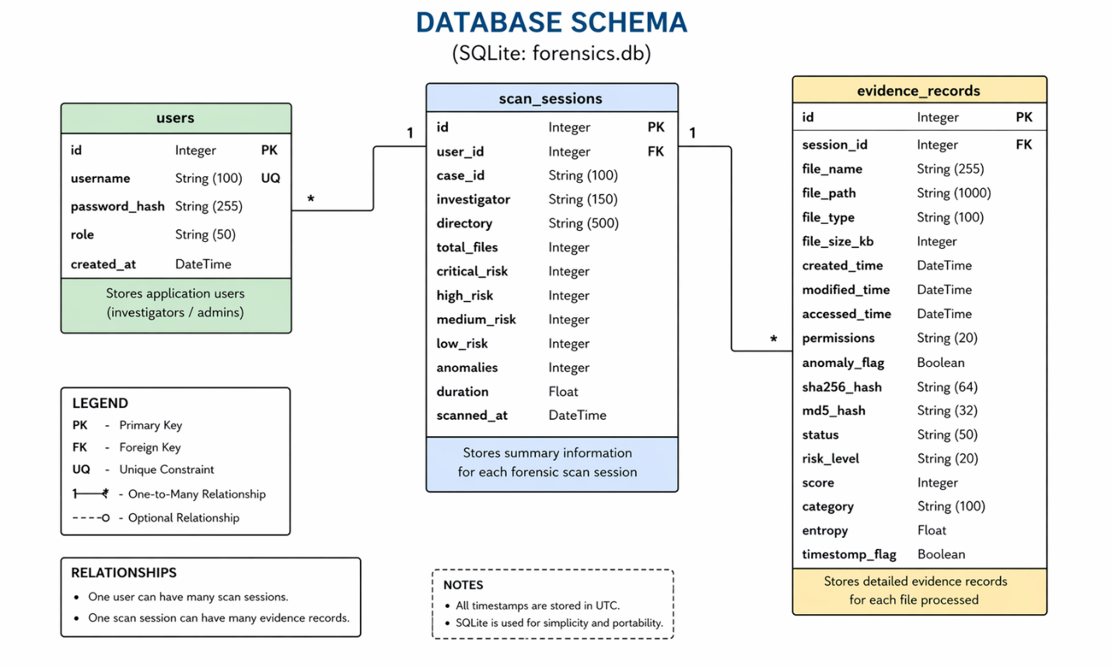
4.2 Data Access Mechanism
Data access is performed exclusively through SQLAlchemy ORM. The Flask application initialises the database with db.create_all() at startup. Evidence records are inserted within a database session context using db.session.add() and db.session.commit(). Queries are performed using SQLAlchemy's query API (e.g., ScanSession.query.order_by(...).all()). The SQLite database file (forensics.db) is stored in the project root directory.
4.3 Data Retention Policies
All scan session data and evidence records are retained indefinitely within the SQLite database. The cascade='all, delete-orphan' relationship on EvidenceRecord ensures that deleting a ScanSession also removes all associated evidence records. Report files (CSV, XLSX, PDF) are written to the reports/ directory and overwritten on each new scan. Log entries are appended to logs/forensic_activity.log.

4.4 Data Migration
The system uses Flask-SQLAlchemy's db.create_all() for automatic schema creation on first run. No migration framework (e.g., Alembic) is currently integrated. Schema changes require manual migration or database recreation. Future versions should integrate Flask-Migrate for production schema management.
5. Interfaces
5.1 User Interfaces
• Web Dashboard (Flask Application): A browser-based interface that provides user authentication, directory scan initiation, real-time scan progress using SSE, and visualization of forensic results through tables, charts, and logs.
• The dashboard also allows users to filter and analyze evidence records, view risk distribution, and download forensic reports in multiple formats.
5.2 External Interfaces
• File System Interface: The scanner module interacts with the operating system file system using Python libraries to perform directory traversal and extract file metadata such as timestamps, size, and permissions.
• Report Interface: The reporting module generates structured forensic reports in CSV, XLSX, and PDF formats and stores them in the local file system for further analysis.
• Database Interface: SQLAlchemy ORM is used to interact with the SQLite database for storing scan sessions, evidence records, and retrieving historical data.
• API Interface: REST APIs and SSE endpoints are used for communication between the frontend and backend, enabling real-time data exchange.
5.3 State and Session Management
User authentication and session management are handled using Flask session mechanisms. Sessions are maintained securely using encrypted cookies to ensure safe user access.
Each forensic scan is assigned a unique identifier, which is used to track scan progress and manage real-time SSE communication between backend and frontend.

5.4 Caching
The system does not implement explicit application-level caching, as real-time accuracy is prioritized over cached responses.
SSE communication is configured to avoid caching so that scan progress is delivered instantly to the user interface.
Static resources such as stylesheets and scripts may be cached by the browser to improve performance and reduce load times.
6. Non-Functional Requirements
6.1 Security Aspects
Aspect | Description
Authentication | All web endpoints (except login) are protected using session-based authentication
Password Security | Passwords are securely stored using hashed formats
Path Validation | Directory paths are validated and resolved to prevent unauthorized access
File Upload Security | Uploaded files are validated and sanitized before processing
Evidence Integrity | SHA256 and MD5 hashes are generated to ensure data integrity
Session Security | User sessions are securely managed and invalidated on logout
Logging | System activities and errors are recorded for audit and traceability

6.2 Performance Aspects
Aspect | Description
Parallel Processing | Multiple files are processed concurrently to improve scan performance
Efficient File Handling | Large files are processed in chunks to reduce memory usage
Optimized Analysis | Selected portions of files are analyzed to maintain performance
Real-Time Updates | SSE is used to stream progress without polling overhead
Database Efficiency | Data is stored efficiently to reduce transaction overhead
Scalability | Performance scales with system resources and file volume

7. References
No. | Reference | Description
1 | Python Standard Library | Used for file handling, OS operations, and core processing
2 | Flask Framework | Used to build the web-based dashboard and API endpoints
3 | SQLAlchemy ORM | Used for database interaction and data modeling
4 | SQLite Database | Used for storing scan sessions and evidence records
5 | openpyxl Library | Used for generating Excel (XLSX) reports
6 | ReportLab Library | Used for generating PDF forensic reports

